Recursion two types,

have to remove left recursion to stop looping forever for the top down parsers

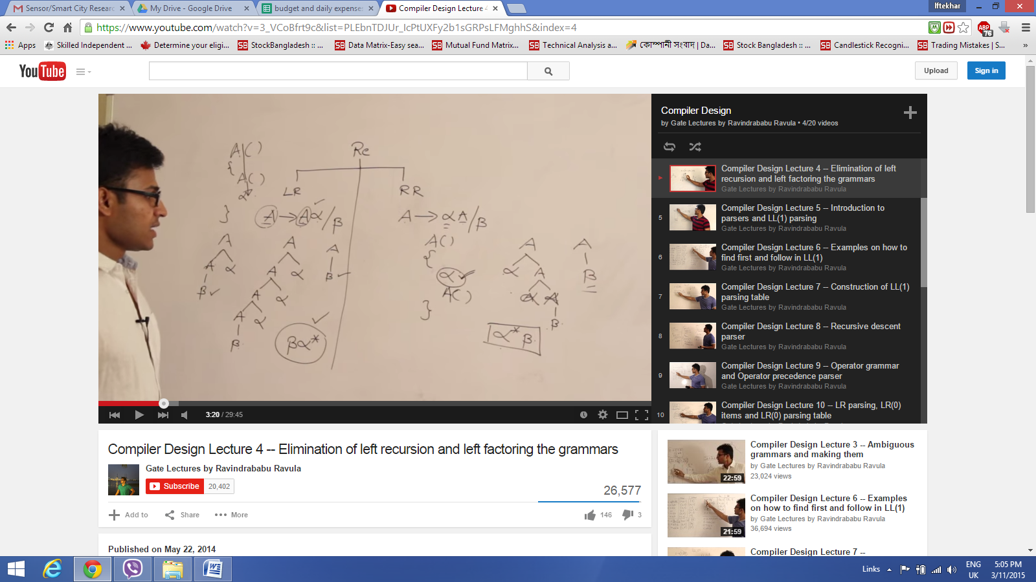

This is how left recursion can be removed, made it right recursive and keeps the grammar still right

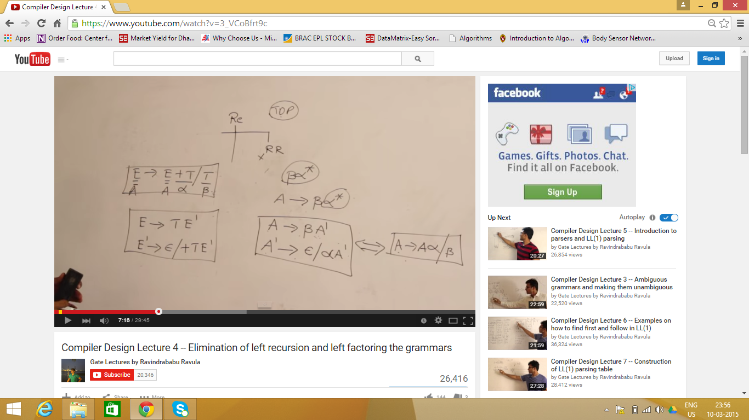

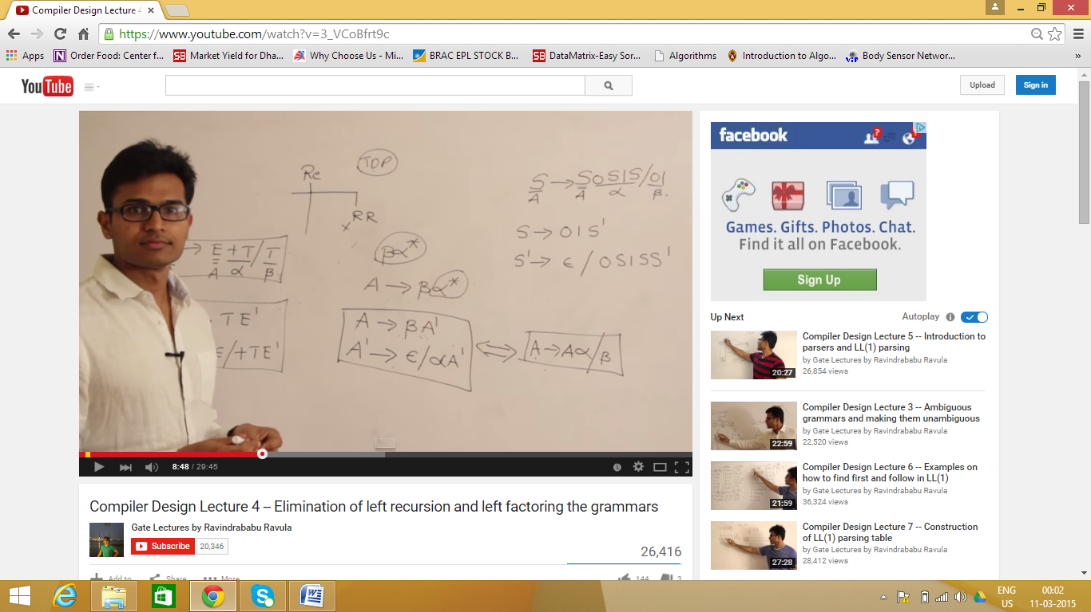

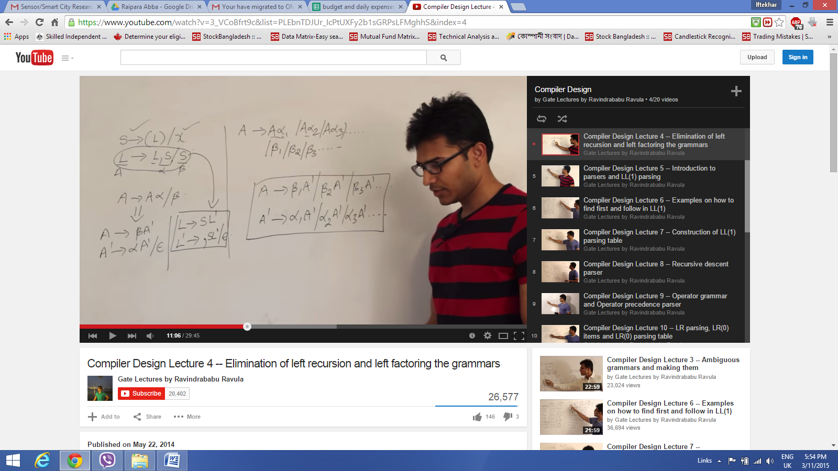

Grammar:

1. Deterministic

2. Non deterministic - having same prefix symbol for production rule

Don't want non deterministic, left recursive and ambiguous

left factoring can eliminate non deterministic to deterministic

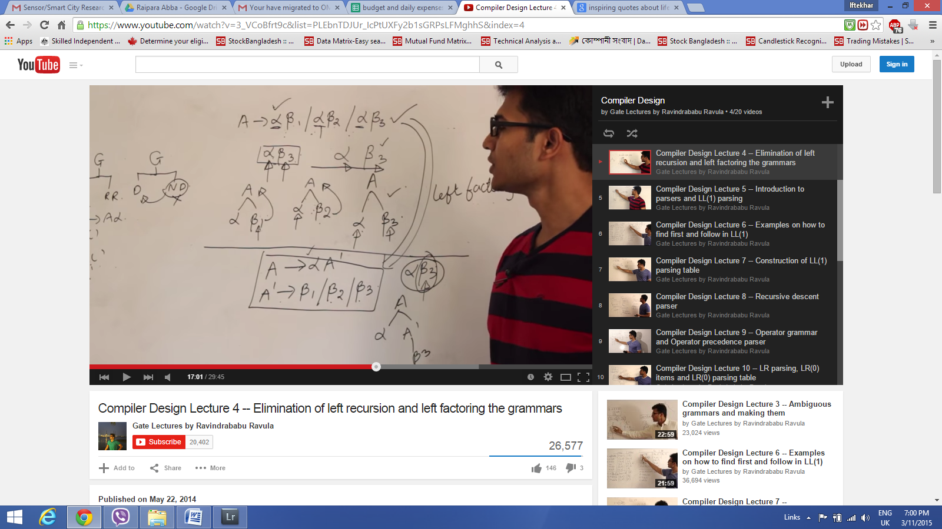

Left factoring might have ambiguity

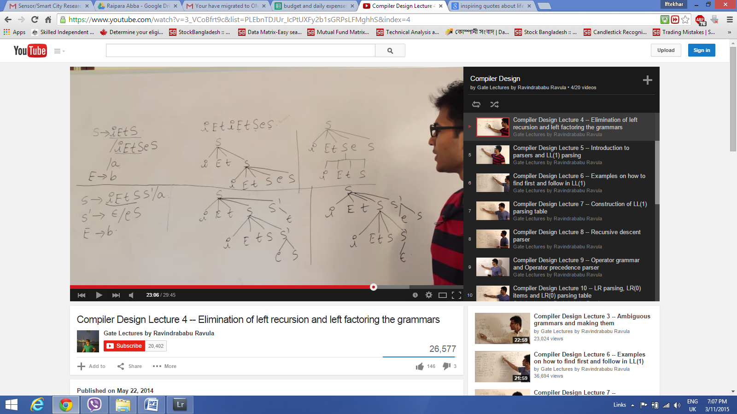

left factoring

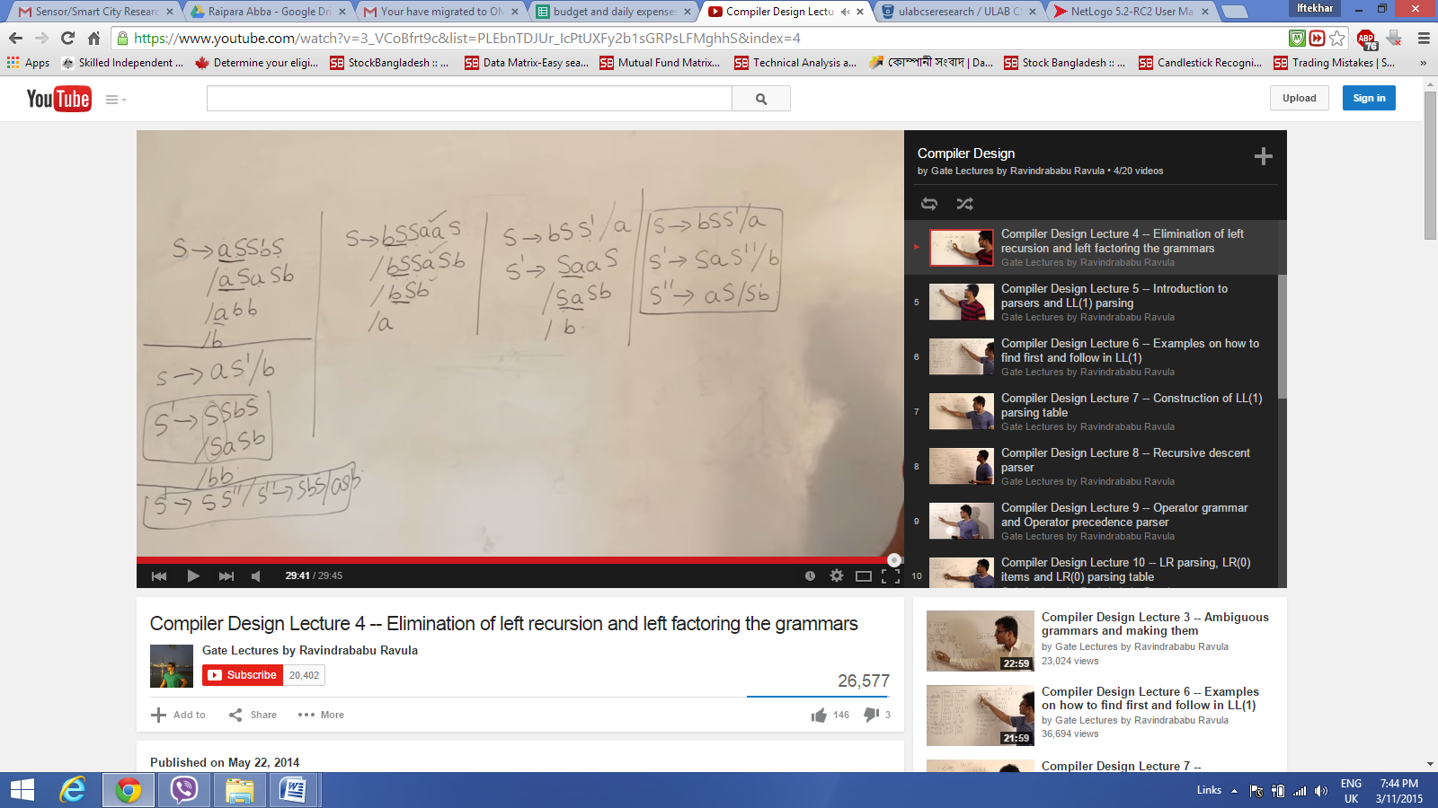

Parsers - nothing but syntax analyser

backtracking - choose first production if that production does not match with the given string then it chooses another production

Bottom up parser also called shift reduced (SR) parser, it uses reverse of right most derivation to build a parse tree

Top down parser uses left most derivation, should not have left recursion, non determinism and ambiguity, only operator precedence parse is the only parser which can even parse an ambiguous grammar

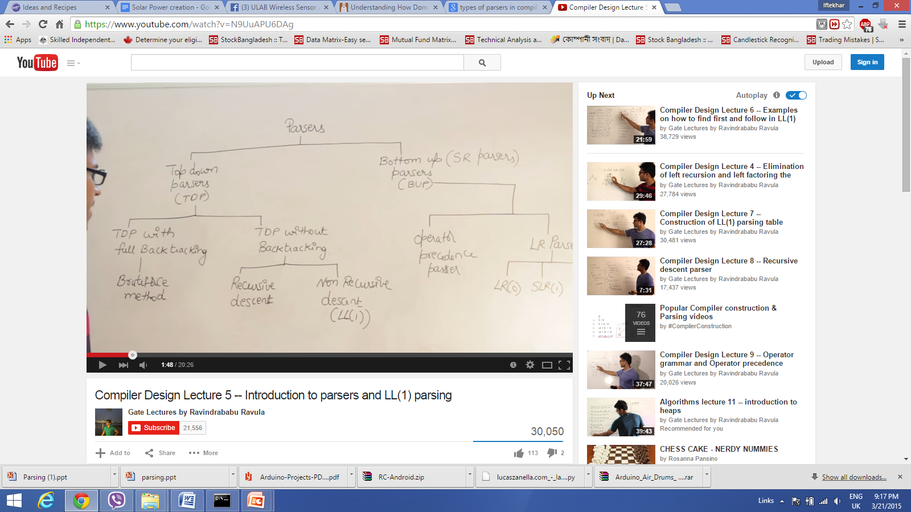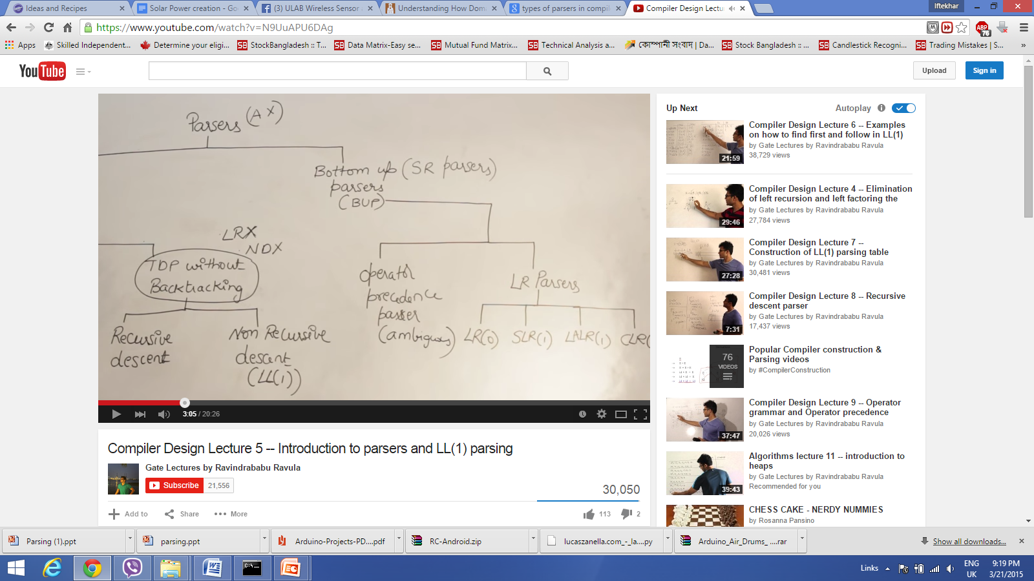

Top down and bottom up, left to right and right to left

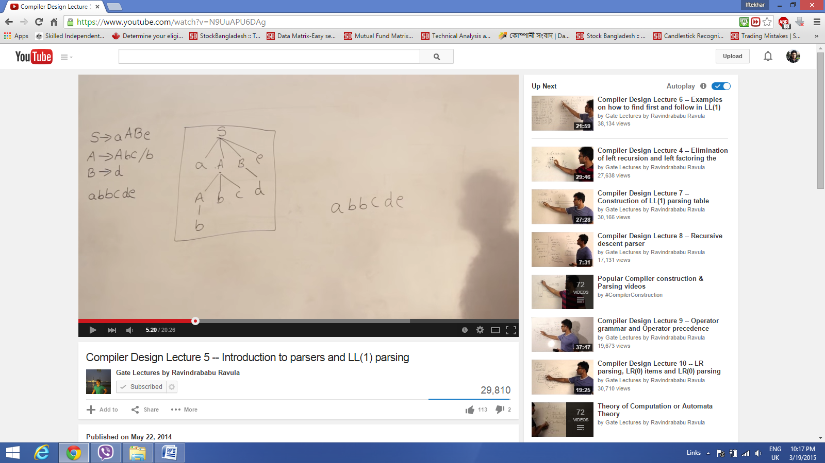 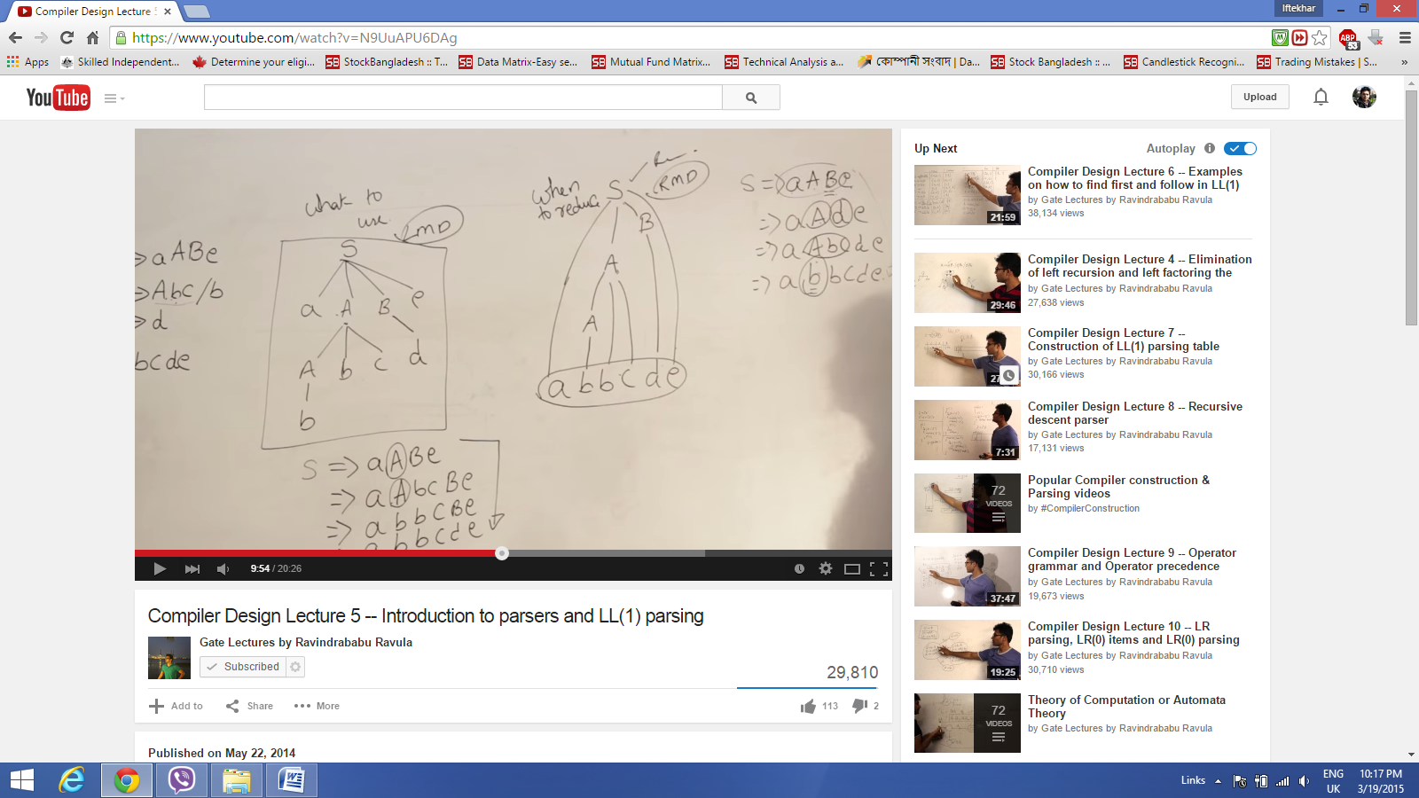

LL(1) parser - scanning input from left to right, left most derivation, 1 is the look ahead, how many numbers of input or symbols it's going to compare or take into consideration

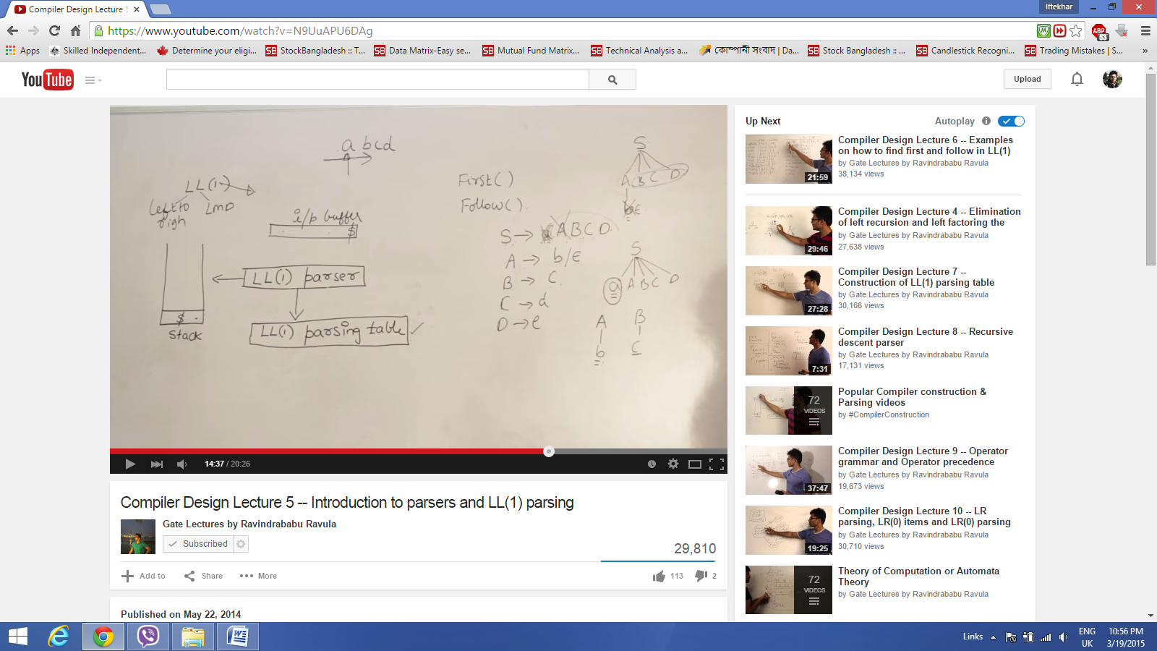

LL(1) has three components

1. parser itself which is the algorithm

2. parsing table is a data structure which we shall construct for a given grammar, by using first and follow function

3. Input buffer: the $ sign shows where should we stop or the end point

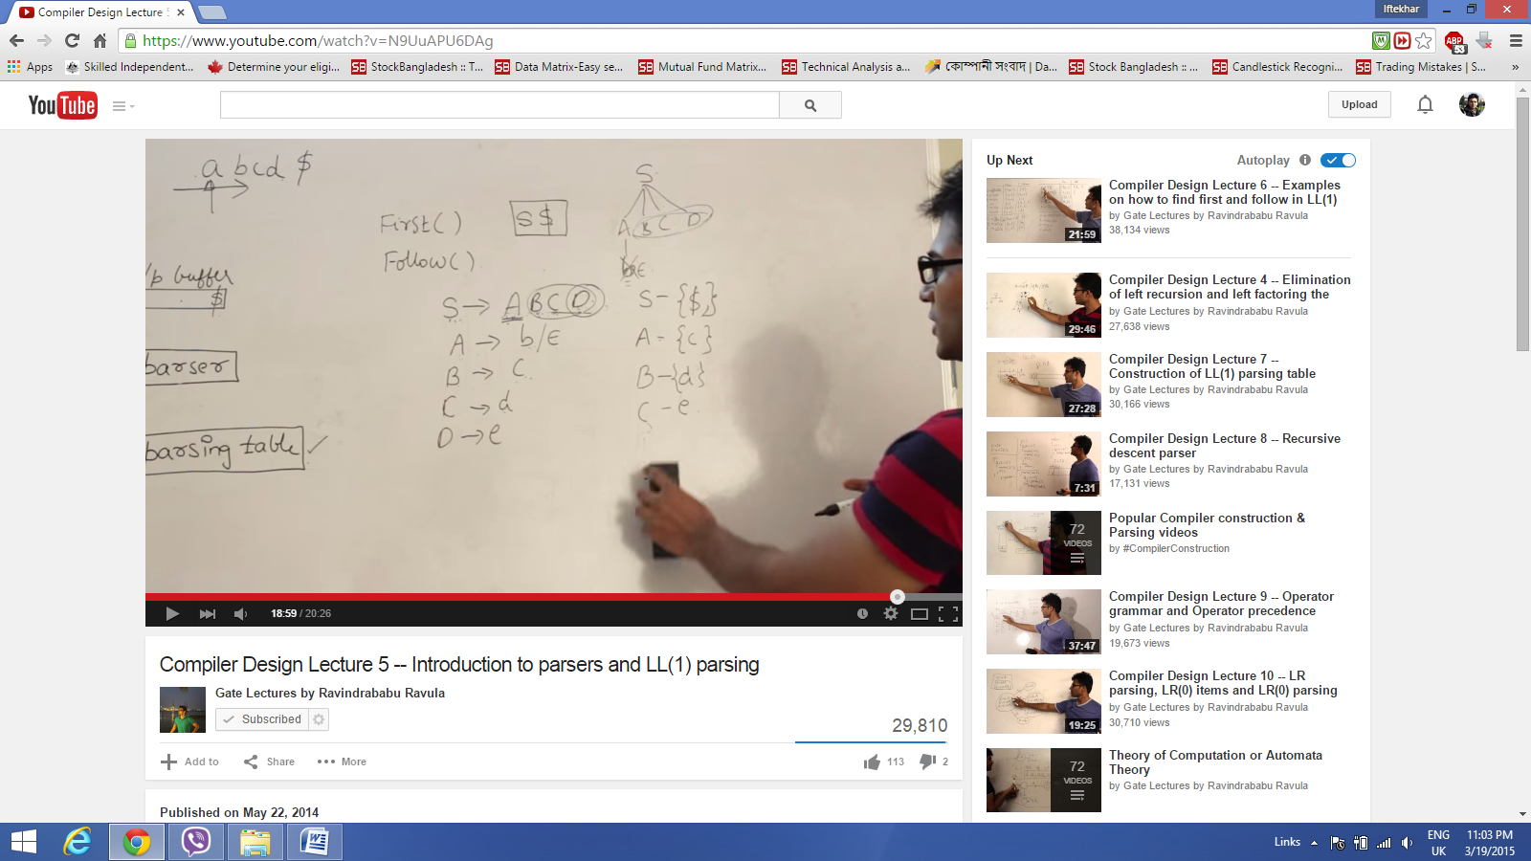

first () - if I have a variable or string, if all the possible combinations are derived from the grammar or production whatever comes at the beginning as a Terminal is called first

follow() - The terminal which could follow a variable in the process of derivation, all the input is actually followed by $ sign as a end of input, actually it is determined by seeing the right hand side of the production, to find out follow look at the occurrences at the right hand side of the productions

* follow never contains epsilon,
* if nothing is following a variable then there would be dollar or follow of left hand side

**Rules for First Sets**

1. If X is a terminal **then** First(X) is just X!
2. If there is a Production X → ε **then** add ε to first(X)
3. If there is a Production X → Y1Y2..Yk **then** add first(Y1Y2..Yk) to first(X)
4. First(Y1Y2..Yk) is **either**
   1. First(Y1) (if First(Y1) doesn't contain ε)
   2. **OR** (if First(Y1) does contain ε) then First (Y1Y2..Yk) is everything in First(Y1) <except for ε > as well as everything in First(Y2..Yk)
   3. If First(Y1) First(Y2)..First(Yk) all contain ε **then** add ε to First(Y1Y2..Yk) as well.

**Rules for Follow Sets**

1. First put $ (the end of input marker) in Follow(S) (S is the start symbol)
2. If there is a production A → aBb, (where a can be a whole string) **then** everything in FIRST(b) except for ε is placed in FOLLOW(B).
3. If there is a production A → aB, **then** everything in FOLLOW(A) is in FOLLOW(B)
4. If there is a production A → aBb, where FIRST(b) contains ε, **then** everything in FOLLOW(A) is in FOLLOW(B)

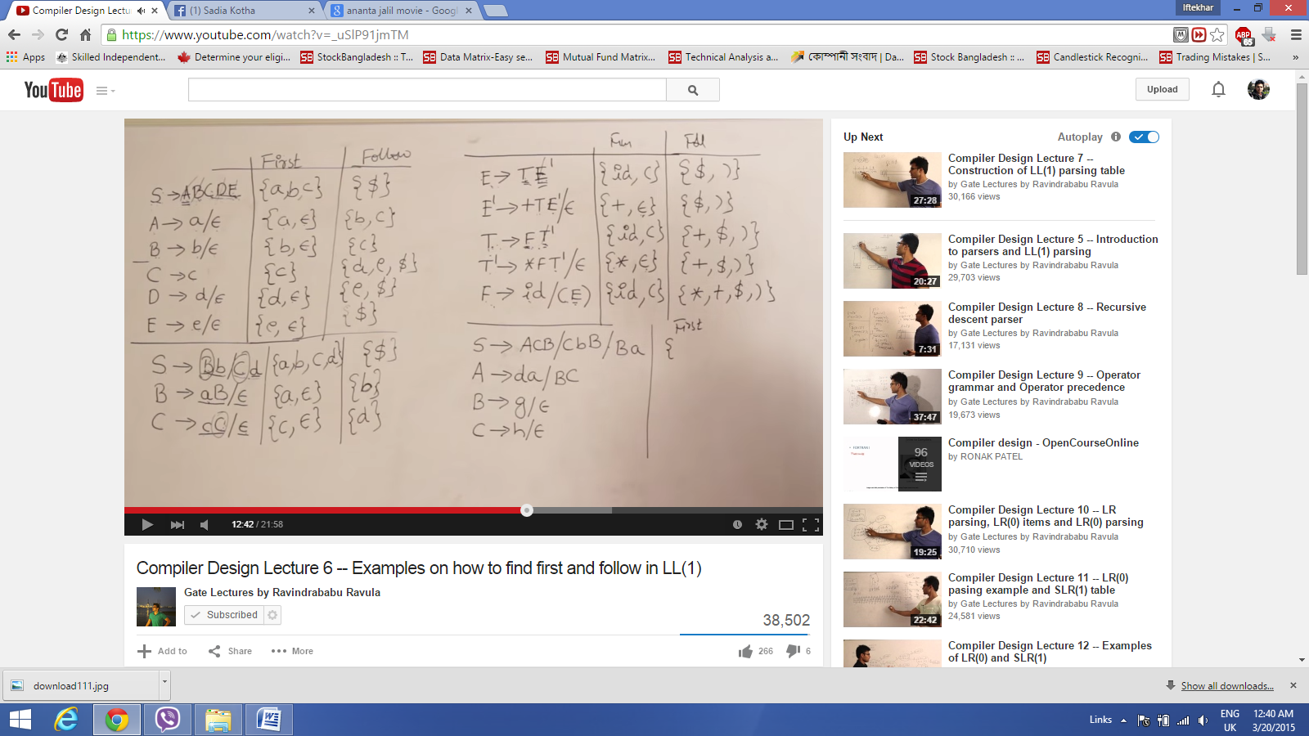

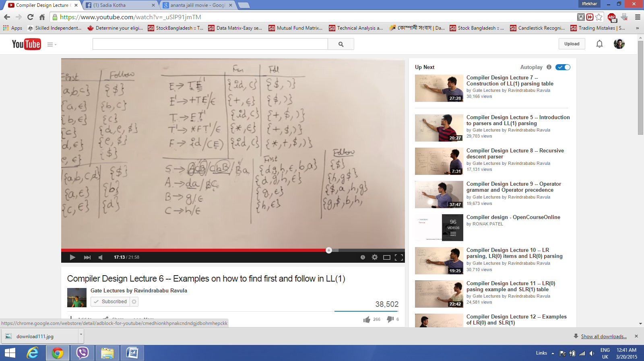

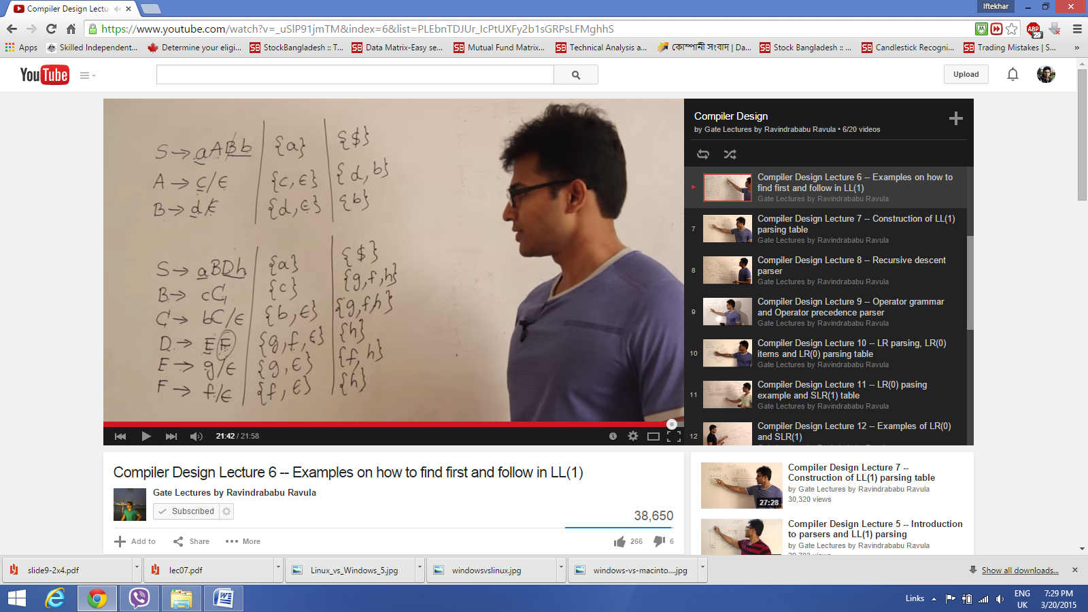

LL(1) parsing table



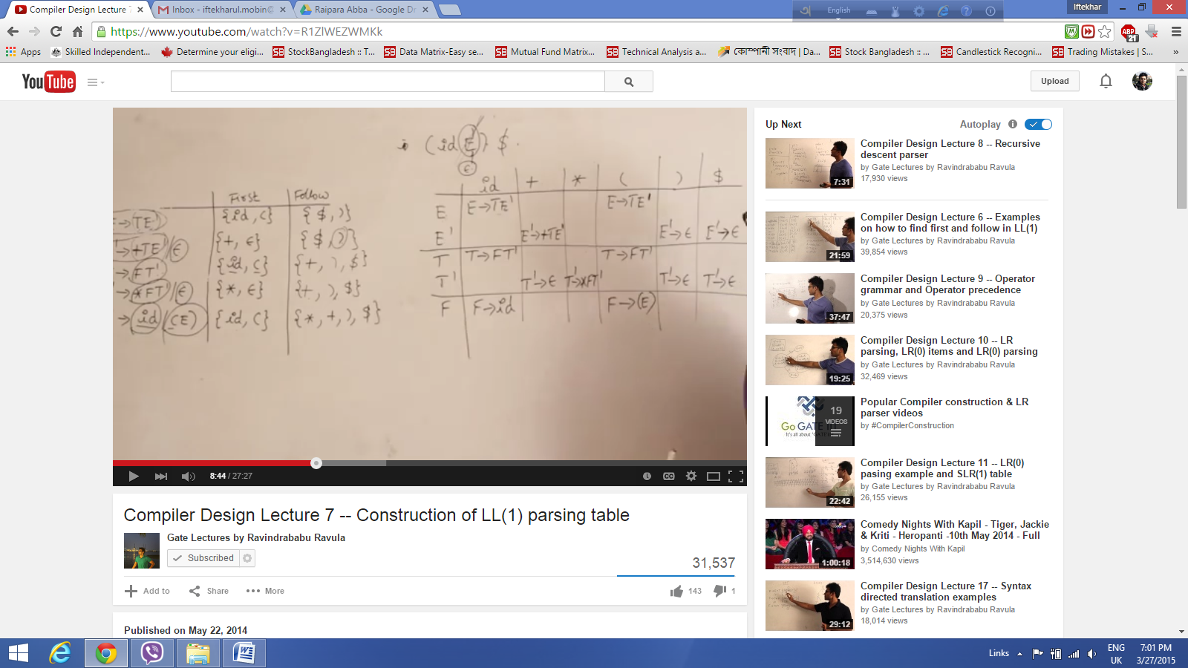

we want to generate (())$ using the first follow and the parsing table, to apply LL(1) parsing method the parser will always check only one symbol at a time

Stack contains $ at the bottom and starts with the first symbol `S`

Replace S with right production so that the left most symbol appears at the top of the stack (LIFO)



In the above example for one Terminal symbol we have only one production rule, when there is only one production rule for one variable for any particular terminal hence there is no confusion which grammar need to use hence this type of grammar is called predictive parser or Top down parser

Hence if any grammar does not maintain this characteristics, the production rules are not mutually exclusive only that case LL(1) parser will not work. So now we can able to find out those scenarios

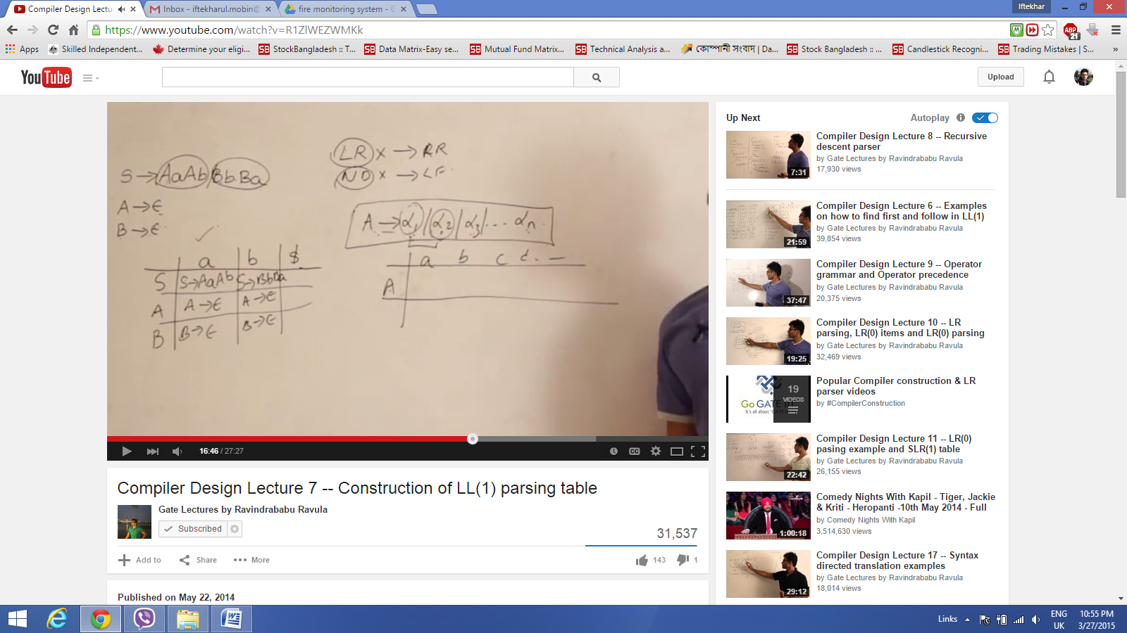

LL(1) does not support LR (left recursion) hence left recursion needs to be removed, non determinism (NDT) needs to be removed by left factoring, there are some grammars which is RR (Right recursive ) and DT still can't be used for LL(1).

In the above example we can see that there is only one production rules in one cell hence LL(1) can be generated from this grammar.

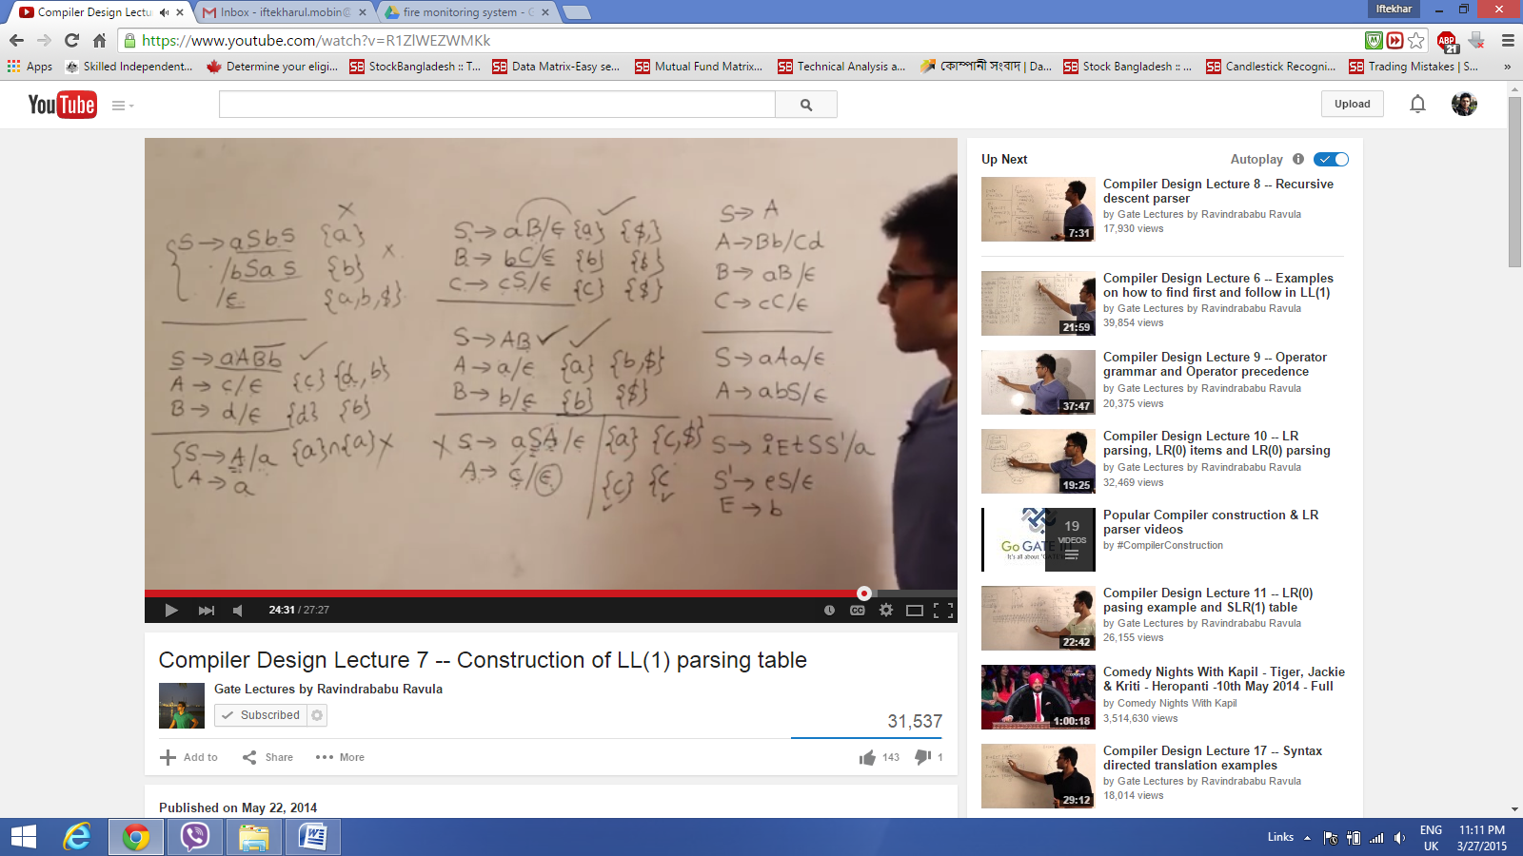

If a variable get more than one alternative and those alternatives haves more than one entry in that case it can't be

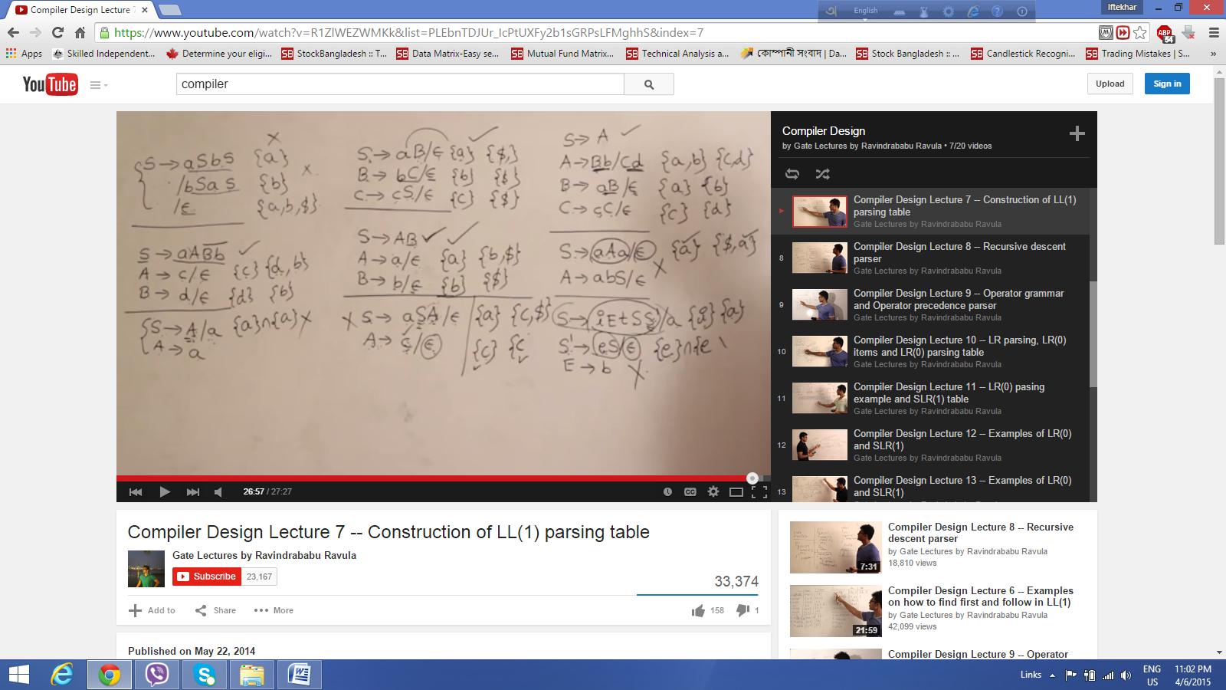

if a derives alpha 1, alpha2 or alpha 3 and any of them are having the same first in that case it i not possible to parse with LL(1) parser

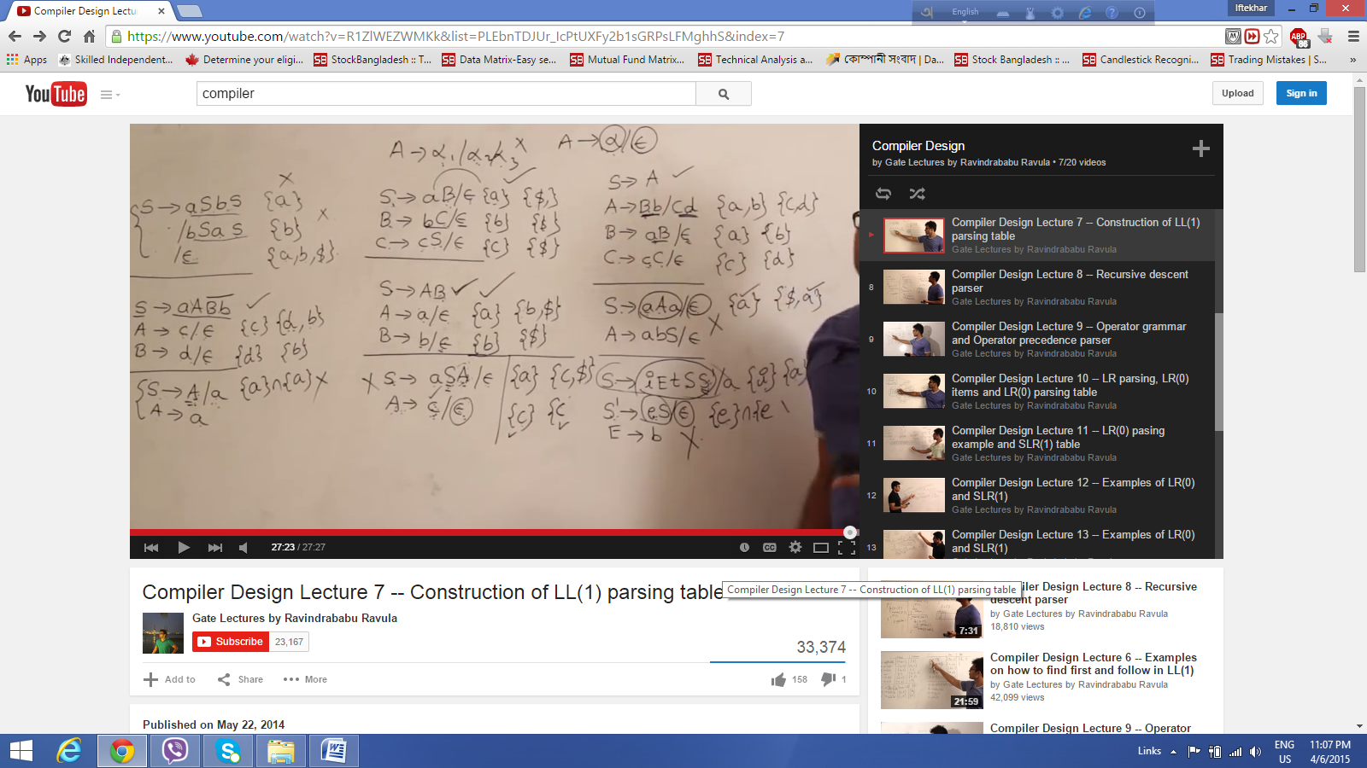

if first of alpha intersect the follow of A and if there remains a common terminal in that case not LL(1)